WERA Rhodesian Park Dolomity  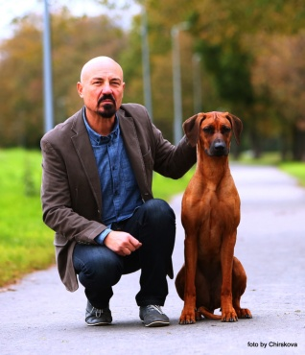 | EZA APAZO  Folwark Zwierzęcy  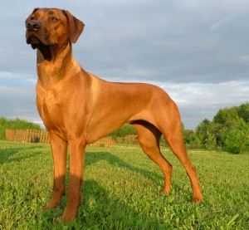 | Awesome ENZO by Luanda  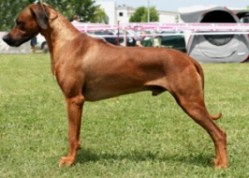 | Emoyeni's Grand Zuberi | Mankoya's Great Gambo
 |  |  |  | Zawadi Zumaridi Johari
 |  |  | Hillvalley's Angel of Luanda | Cheyenne of Ka-Ul-Li's Ridges
 |  |  |  | Ozrhode Wild Inspiration
 |  | Apaszka ZIJU Folwark Zwierzęcy  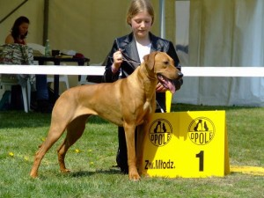 | Jupiter of Parnassus | Kwetu Mahubbah's Fair Play
 |  |  |  | Penelope Echo ofParnassus
 |  |  | Kwetu's ZIZI Mafungabusi | Kwetus Boomerang
 |  |  |  | Daraja Zuzia
 | GLENAHOLM TAARIQ  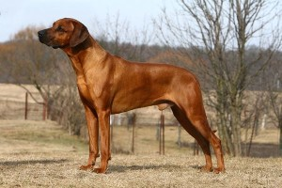 | Amashutu Force B With You | Rijstone War Lord | Amashutu Wild Geese
 |  |  |  | Rijstone Buyani
 |  |  | Skiska Lakota Spirit | Skiska Solitaire Jest
 |  |  |  | Skiska Warrior Princess
 |  | Glenaholm Jemah | Chuclenook Jocko | Rhoban Chason Of Chucklenook
 |  |  |  | Glenaholm Jaising
 |  |  | Danntrig Japa of Glenaholm | Pleasantview Bojelo Of Rooderaai
 |  |  |  | Glenaholm Jyoti of Danntrig

